Waist Circumference (Adolescent Protocol)
Protocol Id | 021601
Description of Protocol | Two protocols for measurements of waist circumference are provided for children (A and B).  For study participants, ages 2 to less than 16 years of age (protocols A and B):  A. National Health and Nutrition Examination Survey (NHANES):  Measurement of the participant’s abdominal (waist) circumference is made at the uppermost lateral border of the ilium using a tape measure.  B. The National Children’s Food Survey (NCFS):  Measurement of participant’s waist circumference is performed midway between the lowest rib and the iliac crest.
Specific Instructions | None
Protocol Text | There are several overarching, critical issues for high-quality data collection of anthropometric measures that optimize the data in gene-environment etiologic research. These issues include: 1) the need for training (and re-training) of study staff in anthropometric data collection; 2) duplicate collection of measurements, especially under field conditions; 3) use of more than one person for proper collection of measurements where required; 4) accurate recording of the protocols and measurement units of data collection; and 5) use of required and properly calibrated equipment.  Under usual field conditions, for reliability, the Anthropometrics Working Group suggests that the measurements are taken in duplicate. A third measurement should be taken if the first two measurements differed by >1.0 cm (1/4") for participants 12 years or older or > 0.5 cm (1/8") for participants 11 years and younger. If it is necessary to take a third measurement, the two closest measurements are averaged. Should the third measurement fall equally between the first two measurements, all three should be averaged.  ***********************************************************  The following protocols are part of examination studies.  Note: Detailed videos illustrating procedure A can be found on the NHANES website at:  http://www.cdc.gov/nchs/products/elec_prods/subject/video.htm  Accessed January 12, 2009.  Note: Hospital gown or correct underclothing should be worn by the participant before measurement.  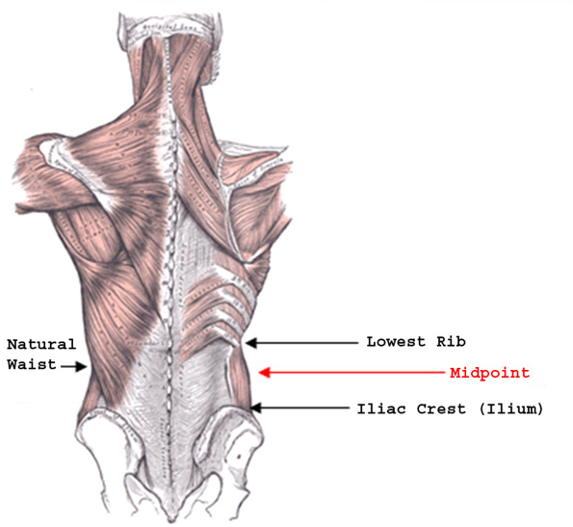  Exhibit 1. Location of Measurement Landmarks between the Lowest Rib and Iliac Crest (Ilium).  Note: Graphic from the "For Good Measure" Study. Personal Communication, M. Forman.  Exhibit 1 displays the anatomical features that are referenced by the various waist circumference measurement protocols.  A. National Health and Nutrition Examination Survey (NHANES):  Abdominal (Waist) Circumference (ages 2 years and older):  Follow the procedures below to obtain this measure:  This measurement should be taken on bare skin.  1. Mark the measurement site: Stand on the participant’s right side. Palpate the hip area to locate the right ilium of the pelvis. You may ask the participant to locate his/her ilium before palpation. With the cosmetic pencil, draw a horizontal line just above the uppermost lateral border of the right ilium. Cross this mark at the midaxillary line, which extends from the armpit down the side of the torso. Exhibit 1 shows the anatomical location of the abdominal waist at the ilium. Repeat the same process on the participant’s left side.  2. Take the measurement: Make sure the participant does not inhale while his/her waist circumference is being measured and that the tape is not twisted. Wrap the tape measure around the individual’s waist as you would a belt, making sure that the zero end of the measure is at the beginning of the circumference. A retractable, tension-controlled steel measuring tape is used.  When measuring the waist, be sure to position the tape in a horizontal plane at the level of the measurement mark. A wall mirror is useful to view the tape to ensure the horizontal alignment of the tape. Another person positioned on the opposite side of the participant should check that the tape sits parallel to the floor and lies snug but does not compress the skin. If a mirror or other person is not available, check the horizontal alignment of the tape before taking the measurement. Always position the zero end of the tape below the section containing the measurement value. Exhibit 1 demonstrates the correct placement of the tape at the ilium. Take the measurement to the nearest 0.1 cm at the end of the participant’s normal expiration.  3. Remove the tape measure and record the result.  4. Repeat the measurement.  Note: Tools are available that include a retractable tape with an anchoring pin that fits into the handle. These tools also assist the participant to lightly cinch the tape. If the investigator uses these tools, the protocol should be altered slightly to comply with directions of the manufacturer. See protocol B for example of use of this tool when measuring a different waist circumference.  Detailed videos illustrating this procedure can be found on the NHANES website at:  http://www.cdc.gov/nchs/products/elec_prods/subject/video.htm  Accessed January 12, 2009.  B. The National Children’s Food Survey (NCFS):  Waist measurement at midpoint between lowest rib and iliac crest (ages 2 to less than 16):  Waist circumference was measured in duplicate using a nonstretch tape measure. First, the midpoint of the distance between the iliac crest (top of hip) and the bottom of the rib cage (10th rib) was identified and marked. Waist circumference was then measured at the midpoint (See Exhibit 1). Measurement is taken to the nearest 0.1 cm.  Additional Points  - If you have problems palpating the rib, ask the participant to breathe in very deeply. Locate the rib and as participant breathes out, follow the rib as it moves down with your finger.  - It is essential that the waist measurement is taken midway between the iliac crest and the lower rib and that the tape is horizontal. Therefore, adjust any clothing items to ensure that measurement is taken per above guidelines: that is, ensure that tape measure follows body lines, not clothing lines.  Interpretation of Findings  The National Heart, Lung, and Blood Institute provides the following guidelines for classifying adults (Exhibit 4, taken from http://www.nhlbi.nih.gov/health/public/heart/obesity/lose_wt/bmi_dis.htm ). Note that these cut points reflect waist circumference using the natural waist protocols (B. Women’s Health Initiative / For Good Measure Study [M. Forman, personal communication]).  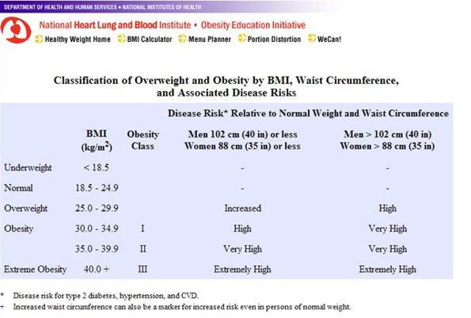  Exhibit 2. Obesity Status of Adults  Taken from http://www.nhlbi.nih.gov/health/public/heart/obesity/lose_wt/bmi_dis.htm, accessed 12/31/08.
Selection Rationale | The state of the science does not indicate a clear choice of protocol at this time. Therefore, the PhenX Anthropometrics Working Group recommends that all body sites (two for children) be utilized in measuring the waist circumference. Furthermore, the type of protocol used should be recorded.  There are two protocols provided by the PhenX Anthropometrics Working Group for use on children. The WG agreed that the NHANES and NCFS protocols for waist circumference were the most feasible to use to obtain the measure in children. It is recommended that both protocols be used and noted along with the measurements collected.
Source | A. National Health and Nutrition Examination Study (NHANES)  Centers for Disease Control and Prevention (CDC), National Center for Health Statistics (NCHS). (2007-2008). National Health and Nutrition Examination Survey Anthropometry Manual. Hyattsville, MD: U.S. Department of Health and Human Services, Centers for Disease Control and Prevention.  D. The National Children’s Food Survey (NCFS): Protocol 2003  http://www.iuna.net/childrens_survey/ncm.pdf  Accessed January 22, 2009.
Language | English
Participant | Aged 2 years and older
Personnel and Training Required | Trained examiner: Individuals need to be trained to identify waist location on persons of varying body mass; training should include dexterity in wrapping the tape around participants, in ensuring horizontal plane for measurement, in use of one standardized tape measure, in positioning of the tape measure; and how to measure adults and children. A pocket guide detailing the protocol is helpful for personnel to carry for review. Training should include methods for recording (i.e., forms or computer screens). Have all personnel practice on the same people to compare reproducibility of measurements and verify against an expert examiner to assure validity; re-train on a regular basis on the same volunteer to ensure reproducibility.
Equipment Needs | A. National Health and Nutrition Examination Survey (NHANES):  Retractable steel measurement tape  B. The National Children’s Food Survey (NCFS):  Flexible measurement tape
Standards | Standard Name ID Source  Common Data Elements (CDE) Person Waist Circumference Value 2793481 CDE Browser  Logical Observation Identifiers Names and Codes (LOINC) Child Waist Circumf 56087-0 LOINC
General References | None
Protocol Type | Physical Measurement
Derived Variables | Waist-to-Height Ratio (WHtR), Waist-to-Hip Ratio (WHR)
Requirements | Requirement Category Required  Average time of greater than 15 minutes in an unaffected individual Average time of greater than 15 minutes in an unaffected individual No  Major equipment This measure requires a specialized measurement device that may not be readily available in every setting where genome wide association studies are being conducted. Examples of specialized equipment are DEXA, Echocardiography, and Spirometry No  Specialized requirements for biospecimen collection This protocol requires that blood, urine, etc. be collected from the study participants. No  Specialized training This measure requires staff training in the protocol methodology and/or in the conduct of the data analysis. No

