Waist Circumference (Adult Protocol)
Protocol Id | 021602
Description of Protocol | The state of the science does not indicate a clear choice of protocol at this time. Therefore, the PhenX Anthropometrics Working Group recommends that all three protocols (three different body sites, protocols A, B, and C below) be utilized in measuring waist circumference in adults. Furthermore, the protocols used should be recorded.  Note: Waist circumference is measured on pregnant females. However, national reference data do not include pregnant females.  For study participants, aged 16 years and older (protocols A-C):  A. National Health and Nutrition Examination Survey (NHANES):  Measurement of the participant’s abdominal (waist) circumference is made at the uppermost lateral border of the ilium using a tape measure.  B. Women’s Health Initiative / For Good Measure Study:  Measurement of the participant’s waist circumference is made at the natural waist.  C. Framingham Heart Study:  Measurement of the participant’s waist circumference is performed at the umbilicus (e.g., navel or belly button).
Specific Instructions | None
Protocol Text | There are several overarching, critical issues for high-quality data collection of anthropometric measures that optimize the data in gene-environment etiologic research. These issues include: 1) the need for training (and re-training) of study staff in anthropometric data collection; 2) duplicate collection of measurements, especially under field conditions; 3) use of more than one person for proper collection of measurements where required; 4) accurate recording of the protocols and measurement units of data collection; and 5) use of required and properly calibrated equipment.  Under usual field conditions, for reliability, the Anthropometrics Working Group suggests that the measurements are taken in duplicate. A third measurement should be taken if the first two measurements differed by >1.0 cm (1/4") for participants 12 years or older or > 0.5 cm (1/8") for participants 11 years and younger. If it is necessary to take a third measurement, the two closest measurements are averaged. Should the third measurement fall equally between the first two measurements, all three should be averaged.  ***********************************************************  The following protocols are part of examination studies.  Note: Detailed videos illustrating procedure A can be found on the NHANES website at:  http://www.cdc.gov/nchs/products/elec_prods/subject/video.htm  Accessed January 12, 2009.  Note: Hospital gown or correct underclothing should be worn by the participant before measurement.  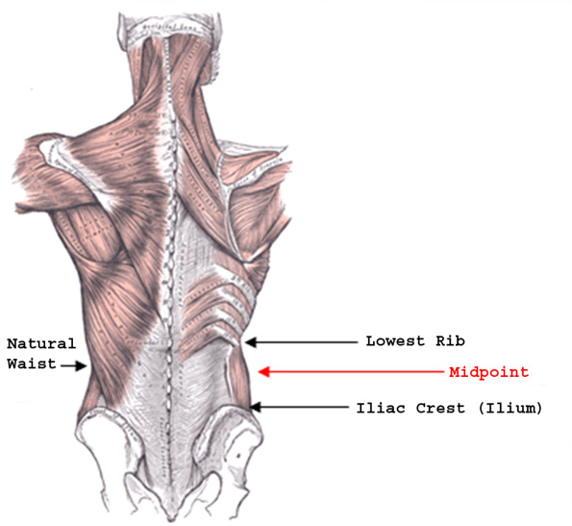  Exhibit 1. Location of Measurement Landmarks between the Lowest Rib and Iliac Crest (Ilium).  Note: Graphic from the "For Good Measure" Study. Personal Communication, M. Forman.  Exhibit 1 displays the anatomical features that are referenced by the various waist circumference measurement protocols.  A. National Health and Nutrition Examination Survey (NHANES):  Abdominal (Waist) Circumference (ages 2 years and older):  Follow the procedures below to obtain this measure:  This measurement should be taken on bare skin.  - Mark the measurement site: Stand on the participant’s right side. Palpate the hip area to locate the right ilium of the pelvis. You may ask the participant to locate his/her ilium before palpation. With the cosmetic pencil, draw a horizontal line just above the uppermost lateral border of the right ilium. Cross this mark at the midaxillary line, which extends from the armpit down the side of the torso. Exhibit 1 shows the anatomical location of the abdominal waist at the ilium. Repeat the same process on the participant’s left side.  - Take the measurement: Make sure the participant does not inhale while his/her waist circumference is being measured and that the tape is not twisted. Wrap the tape measure around the individual’s waist as you would a belt, making sure that the zero end of the measure is at the beginning of the circumference. A retractable, tension-controlled steel measuring tape is used.  When measuring the waist, be sure to position the tape in a horizontal plane at the level of the measurement mark. A wall mirror is useful to view the tape to ensure the horizontal alignment of the tape. Another person positioned on the opposite side of the participant should check that the tape sits parallel to the floor and lies snug but does not compress the skin. If a mirror or other person is not available, check the horizontal alignment of the tape before taking the measurement. Always position the zero end of the tape below the section containing the measurement value. Exhibit 1 demonstrates the correct placement of the tape at the ilium. Take the measurement to the nearest 0.1 cm at the end of the participant’s normal expiration.  - Remove the tape measure and record the result.  - Repeat the measurement.  Note: Tools are available that include a retractable tape with an anchoring pin that fits into the handle. These tools also assist the participant to lightly cinch the tape. If the investigator uses these tools, the protocol should be altered slightly to comply with directions of the manufacturer. See protocol B for use of this tool when measuring a different waist circumference.  Detailed videos illustrating this procedure can be found on the NHANES website at:  http://www.cdc.gov/nchs/products/elec_prods/subject/video.htm  Accessed January 12, 2009.  B. Women’s Health Initiative / For Good Measure Study  Note: The following protocol is from the Women’s Health Initiative (WHI), a very large epidemiologic study of women only. A similar protocol was used successfully as part of the "For Good Measure" study, which includes both men and women.  Natural waist, also referred to as the narrowest part of the torso (ages 16 and older):  The natural waist is the narrowest part of the torso (viewed from behind) at the end of an expiration of breath (see Exhibit 2). The measurement is recorded to nearest half-centimeter, rounded up. Note that the narrowest spot may be difficult to locate in extremely obese participants.  This measurement should be taken on bare skin so that clothing effects can be removed from the measurement. Therefore, the WHI protocol procedures listed below have been altered to indicate that the participant should remove or adjust clothing to reveal her waist for measurement. This protocol uses a measuring tape that measures in centimeters.  1. Instruct the participant to remove or adjust any clothing, belts, girdles, etc., so that the measurement can be taken on bare skin.  2. Instruct the participant to stand with her weight distributed evenly on both feet, abdomen relaxed, arms at her sides, and feet together.  3. Facing the participant, place the tape measure in a horizontal plane at the level of the natural waist, which is the narrowest part of the torso. An assistant may be needed to help position the tape in a horizontal plane. Alternatively, a wall-mounted mirror can be used to assist with positioning the tape in the horizontal position. If it is difficult to identify a waist narrowing, measure the smallest horizontal circumference in the area between the participant’s ribs and iliac crest.  4. Ensure that the zero end of the tape is below the measurement value.  5. Verify that the participant is standing erect and that the tape measure is horizontal.  6. Take the waist measurement at the end of a normal expiration, without the tape measure compressing the skin.  7. Record the waist measurement on [the data form], rounding up to the nearest half centimeter.  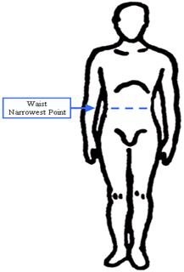  Exhibit 2. Location of Waist Measured at Narrowest Point  Graphic from For Good Measure Study. Personal Communication, M. Forman.  C. Framingham Heart Study:  Waist circumference measured at the umbilicus (ages 16 years and older):  The waist circumference is the horizontal plane centered on the umbilicus of the participant (see Exhibit 3). Note that the umbilicus may be embedded in sagging fat in extremely obese participants.  Follow the procedures below to obtain this measure.  1. Participant stands erect, arms hanging loosely at sides, weight equally distributed on both feet, head facing straight ahead.  2. The technician will take the gown from the back and place it over the shoulder of the participant. The technician will ask the participant to bend their arms at the elbow and hold the gown in place.  3. Apply anthropometric tape at the level of the umbilicus.  4. Apply tape snugly but not tightly.  5. Make sure the tape is horizontal and not twisted, checking from both the front and back by using 2 mirrors mounted to the wall.  6. Before recording measurement, ask the participant to fully relax their shoulders.  7. Record measurement to the nearest 1/4 inch, rounding down.  For off-site visits, the waist measurement will be done without using a mirror. A code should be entered to capture this as a protocol modification.  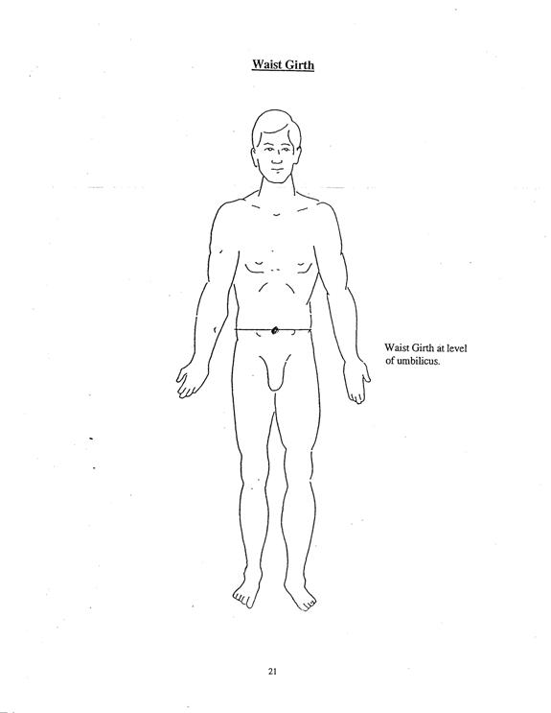  Exhibit 3. Location of Measurement at Umbilicus  Graphic from the Framingham Heart Study. Personal Communication, J. Murabito.  Interpretation of Findings  The National Heart, Lung, and Blood Institute provides the following guidelines for classifying adults (Exhibit 4, taken from http://www.nhlbi.nih.gov/health/public/heart/obesity/lose_wt/bmi_dis.htm ). Note that these cut points reflect waist circumference using the natural waist protocols (B. Women’s Health Initiative / For Good Measure Study [M. Forman, personal communication]).  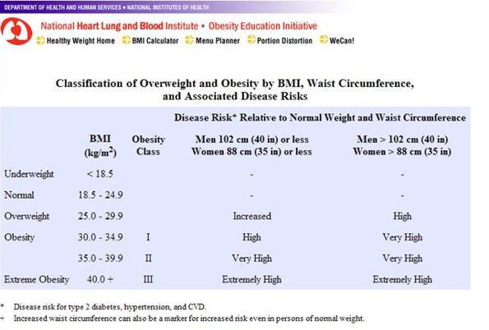  Exhibit 4. Obesity Status of Adults  Taken from http://www.nhlbi.nih.gov/health/public/heart/obesity/lose_wt/bmi_dis.htm, accessed 12/31/08.
Selection Rationale | The state of the science does not indicate a clear choice of protocol at this time. Therefore, the PhenX Anthropometrics Working Group recommends that all body sites (three for adults) be utilized in measuring the waist circumference. Furthermore, the type of protocol used should be recorded.
Source | A. National Health and Nutrition Examination Study (NHANES) 2007-2008 Anthropometry Procedures Manualhttp://www.cdc.gov/nchs/data/nhanes/nhanes_07_08/manual_an.pdf  Accessed January 22, 2009.  B. Women’s Health Initiative / For Good Measure Study  WHI: Personal Communication, Nancy Morris (NHLBI)  For Good Measure Study: Personal Communication, Michele Forman (MD Anderson Cancer Center)  C. Framingham Heart Study - Offspring Cohort, Exam 5, 1994  http://tinyurl.com/6n6wez  Accessed January 22, 2009.
Language | English, Spanish
Participant | Aged 2 years and older
Personnel and Training Required | Trained examiner: Individuals need to be trained to identify waist location on persons of varying body mass; training should include dexterity in wrapping the tape around participants, in ensuring horizontal plane for measurement, in use of one standardized tape measure, in positioning of the tape measure; and how to measure adults and children. A pocket guide detailing the protocol is helpful for personnel to carry for review. Training should include methods for recording (i.e., forms or computer screens). Have all personnel practice on the same people to compare reproducibility of measurements and verify against an expert examiner to assure validity; re-train on a regular basis on the same volunteer to ensure reproducibility.
Equipment Needs | A. National Health and Nutrition Examination Survey (NHANES):  Retractable steel measurement tape  B. Women’s Health Initiative / For Good Measure Study:  Flexible measurement tape that measures in centimeters  C. Framingham Heart Study:  Flexible measurement tape
Standards | Standard Name ID Source  Common Data Elements (CDE) Person Waist Circumference Value 2793481 CDE Browser  Logical Observation Identifiers Names and Codes (LOINC) Adult Waist Circumf 56086-2 LOINC
General References | None
Protocol Type | Physical Measurement
Derived Variables | Waist-to-Hip Ratio (WHR), Waist-to-Height Ratio (WHtR)
Requirements | Requirement Category Required  Average time of greater than 15 minutes in an unaffected individual Average time of greater than 15 minutes in an unaffected individual No  Major equipment This measure requires a specialized measurement device that may not be readily available in every setting where genome wide association studies are being conducted. Examples of specialized equipment are DEXA, Echocardiography, and Spirometry No  Specialized requirements for biospecimen collection This protocol requires that blood, urine, etc. be collected from the study participants. No  Specialized training This measure requires staff training in the protocol methodology and/or in the conduct of the data analysis. No

