Alcohol - Maximum Drinks in 24 Hours
Protocol Id: | 30401
Description of Protocol | Lifetime measurement of the largest number of drinks respondent has consumed. The PhenX Working Group modified this question from the source so that it is compatible with the Alcohol - Lifetime Use measure. The original question defined the time period for maximum consumption as the last year.
Specific Instructions | Respondents are only asked this question if they answered "yes" to the Alcohol - Lifetime Use measure. If the respondent is male and reports consuming 5 or more drinks or if the respondent is female and reports consuming 4 or more drinks, then the researcher can extract binge drinking. Alcohol is defined as any type of alcohol (including coolers, beer, wine, champagne) and liquor (e.g., whiskey, rum, gin, vodka, scotch, or liqueurs.)
Protocol: | - What was the LARGEST number of drinks that you ever drank in a single day?  ___ Number  [ ] Never drank  [ ] Refused  [ ] Don’t know  Notes to interviewer:  - Definition of a standard drink: 1 12oz bottle of beer, 1 glass 4oz non-fortified wine, 1 mixed drink with 1oz liquor.  - If respondent needs a visual reference for the size of a drink, the flashcards from the Wave 1 National Epidemiologic Survey on Alcohol and Related Conditions (NESARC) study are provided below:  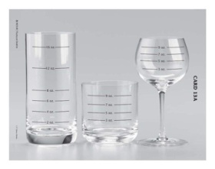  Card 1A. Cooler ounce size  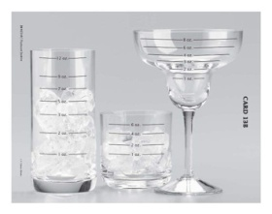  Card 1B. Cooler ounce size  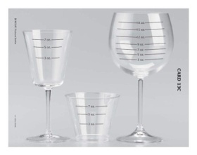  Card 1C. Cooler ounce size  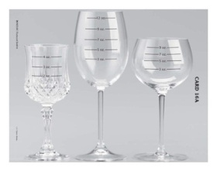  Card 2A. Wine ounce size  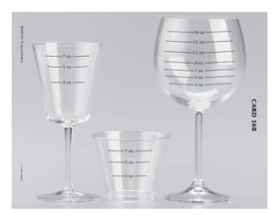  Card 2B. Wine ounce size  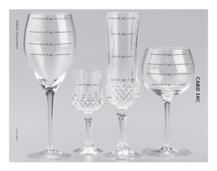  Card 2C. Wine ounce size  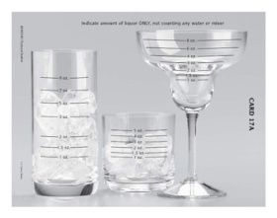  Card 3A. Liquor ounce size  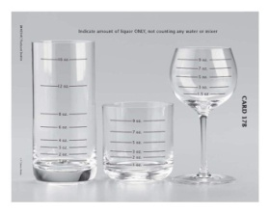  Card 3B. Liquor ounce size  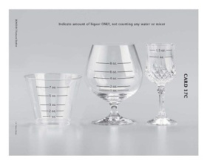
Selection Rationale | The protocol from the Alcohol Use Disorder and Associated Disabilities Interview Schedule (AUDADIS) was chosen because it was used in a large epidemiological study of adults of a wide age range and different ethnicities (Wave 1 included 43,093 Americans; in Wave 2, 34,653 members of the original cohort were reinterviewed). The measures from this survey have been validated and psychometrically tested.
Source | National Institute on Alcohol Abuse and Alcoholism (NIAAA) National Epidemiologic Survey on Alcohol and Related Conditions. Wave 1 (NESARC - WAVE 1). Alcohol Use Disorder and Associated Disabilities Interview Schedule - Diagnostic and Statistical Manual of Mental Disorders. Fourth Edition Version (AUDADIS-IV). Section 2A. Modified question 8c and Flashcard Booklet, Flashcards 13A-C, 16A-C, and 17A-C.  Grant, B. F., Dawson, D. A., Stinson, F. S., Chou, P. S., Kay, W., & Pickering, R. (2003). The Alcohol Use Disorder and Associated Disabilities Interview Schedule-IV (AUDADIS-IV): Reliability of alcohol consumption, tobacco use, family history of depression and psychiatric diagnostic modules in a general population sample. Drug and Alcohol Dependence, 71(1), 7-16.
Language | English, Available in other languages
Participant | ≥18 years of age
Personnel and Training Required | Interviewer must be trained and found competent to conduct personal interviews with individuals from the general population. The interviewer should be trained to prompt respondents further if a "don't know" response is provided.
Equipment Needs | While the Alcohol Use Disorder and Associated Disabilities Interview Schedule-IV (AUDADIS-IV) instrument was developed for administration by computer, the PhenX Working Group acknowledges that this question can be administered in a noncomputerized format. Hasin et al. (1997) and Grant et al. (1995) used the AUDADIS in paper-and-pencil format, while Grant et al. (2003) obtained data with the computerized format.
Standards: | Standard Name ID Source  Common Data Element (CDE) Alcohol 24 hours Maximum Consumption Number 2820804 CDE Browser  Logical Observation Identifiers Names and Codes (LOINC) Alcohol max drinks 24H proto 62549-1 LOINC
General references | Grant, B. F., Dawson, D. A., Stinson, F. S., Chou, P. S., Kay, W., & Pickering, R. (2003). The Alcohol Use Disorder and Associated Disabilities Interview Schedule-IV (AUDADIS-IV): Reliability of alcohol consumption, tobacco use, family history of depression and psychiatric diagnostic modules in a general population sample. Drug and Alcohol Dependence, 71(1), 7-16.  Grant, B. F., Harford, T. C., Dawson, D. A., Chou, P. S., & Pickering, R. P. (1995). The Alcohol Use Disorder and Associated Disabilities Interview Schedule (AUDADIS): Reliability of alcohol and drug modules in a general population sample. Drug and Alcohol Dependence, 39(1), 37-44.  Hasin, D., Carpenter, K. M., McCloud, S., Smith, M., & Grant, B. F. (1997). The Alcohol Use Disorder and Associated Disabilities Interview Schedule (AUDADIS): Reliability of alcohol and drug modules in a clinical sample. Drug and Alcohol Dependence, 44(2-3), 133-141.  National Institute on Alcohol Abuse and Alcoholism (NIAAA). (2004). NIAAA Newsletter (NIH Publication No. 04-5346).
Protocol Type | Interviewer-administered questionnaire
Derived Variables | Binge drinking:  Male respondent: 5 or more drinks  Female respondent: 4 or more drinks
Requirements | Requirement Category Required  Major equipment This measure requires a specialized measurement device that may not be readily available in every setting where genome wide association studies are being conducted. Examples of specialized equipment are DEXA, Echocardiography, and Spirometry No  Specialized training This measure requires staff training in the protocol methodology and/or in the conduct of the data analysis. No  Specialized requirements for biospecimen collection This protocol requires that blood, urine, etc. be collected from the study participants. No  Average time of greater than 15 minutes in an unaffected individual Average time of greater than 15 minutes in an unaffected individual No
Process and Review: | The Expert Review Panel has not reviewed this measure yet.

