Neck Circumference
Protocol Id | 021201
Description of Protocol | Neck circumference is measured just below the larynx and perpendicular to the long axis of the neck. Individuals should look straight ahead with shoulders down (not hunched).
Specific Instructions | None
Protocol Text | There are several overarching, critical issues for high-quality data collection of anthropometric measures that optimize the data in gene-environment etiologic research. These issues include: (1) the need for training (and retraining) of study staff in anthropometric data collection; (2) duplicate collection of measurements, especially under field conditions; (3) use of more than one person for proper collection of measurements, where required; (4) accurate recording of the protocols and measurement units of data collection; and (5) use of required and properly calibrated equipment.  Under usual field conditions, for reliability, the PhenX Anthropometrics Working Group suggests that the measurements are taken in duplicate. A third measurement should be taken if the first two measurements differed by >1.0 cm (1/4"). If it is necessary to take a third measurement, the two closest measurements are averaged. Should the third measurement fall equally between the first two measurements, all three should be averaged.  ******************************************  The following protocol is part of an examination study.  - Participant stands erect, arms hanging loosely at sides, weight equally distributed on both feet, head positioned in the Frankfort horizontal plane position (see Exhibit 1).  - Standing to face the left side of the participant, identify the thyroid cartilage by gentle palpation of the neck. Gently place your left index and second fingers on the front of the neck and ask the participant to swallow to help find the correct spot. You should feel a slight depression.  - Place the superior border of the anthropometric tape just inferior to the laryngeal prominence.  - Apply the tape snugly, but not tightly, perpendicular to the long axis of the neck, which is not necessarily in the horizontal plane but approximately a 90-degree angle to the long axis.  - Record the neck circumference to the nearest 1/4 inch (or 0.1 cm), rounding down.  - The pressure on the tape should be the minimum required to maintain skin contact.  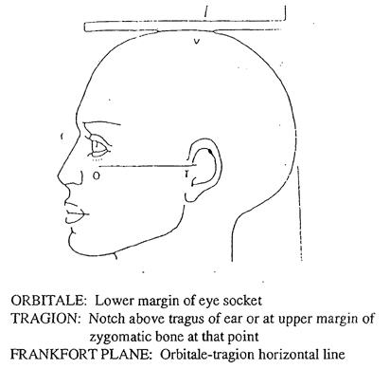  Exhibit 1. Frankfort Horizontal Plane
Selection Rationale | The Neck Circumference Protocol was taken from the Framingham Heart Study (FHS), a large prospective cohort study to identify the common factors or characteristics that contribute to cardiovascular disease.
Source | U.S. Department of Health and Human Services. National Institutes of Health. National Heart, Lung, and Blood Institute and Boston University. Framingham Heart Study (FHS). Offspring Cohort. Clinical Exam 7.
Language | English
Participant | Participants ≥18 years of age
Personnel and Training Required | Technicians should be trained in the basic techniques of anthropometric measurements.
Equipment Needs | Flexible measurement tape
Standards | Standard Name ID Source  Common Data Elements (CDE) Person Neck Circumference Value 2793491 CDE Browser  Logical Observation Identifiers Names and Codes (LOINC) Neck circumference proto 62413-0 LOINC
General References | None
Protocol Type | Physical Measurement
Derived Variables | None
Requirements | Requirement Category Required  Average time of greater than 15 minutes in an unaffected individual Average time of greater than 15 minutes in an unaffected individual No  Major equipment This measure requires a specialized measurement device that may not be readily available in every setting where genome wide association studies are being conducted. Examples of specialized equipment are DEXA, Echocardiography, and Spirometry No  Specialized requirements for biospecimen collection This protocol requires that blood, urine, etc. be collected from the study participants. No  Specialized training This measure requires staff training in the protocol methodology and/or in the conduct of the data analysis. No

